Project Design Phase-II

Data Flow Diagram & User Stories

**Data Flow Diagram:**

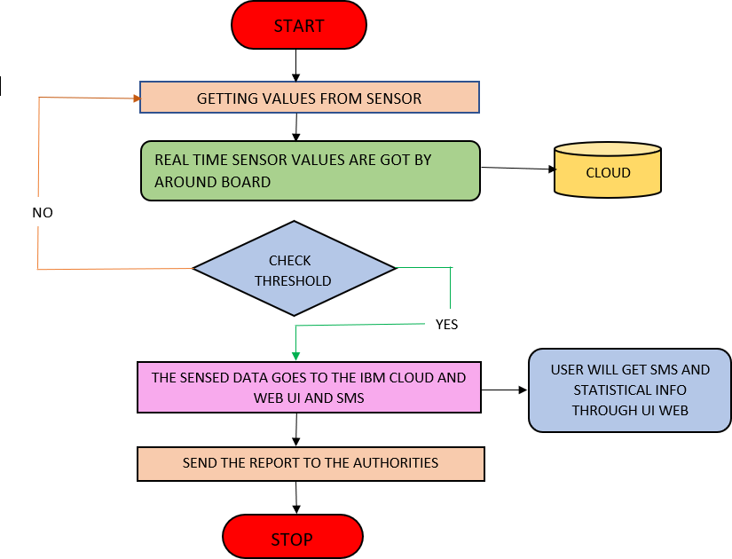

**User Stories**

**User Type Functional Requirement (Epic)**

**User Story**

# Number

**User Story / Task Acceptance criteria Priority**

# Release

Customer (Mobile user)

Registration USN-1

USN-2

USN-3

USN-4

As a user, I can register for the application by entering email, password, and confirming my password.

As a user, I will receive a confirmation email once I have registered for the application

As a user, I can register for the application through Google

As a user, I can register for the application through Gmail

I can access my

account/dashboard

I can receive e confirmation email & click confirm

I can register & access the dashboard with Google

I can register through the mail.

High

High

High

Medium

Sprint-1

Sprint-2

Sprint-1

Sprint-2

Login USN-5

As a user, I can log into the application by entering email, password & captcha

I can receive login credentials.

High Sprint-1

Interface

USN-6

As a user, the interface should be user-friendly I can able to access manner easily.

Medium

Sprint-1

Customer (Web dashboard user)

USN-7

As a user, I can access the specific info(ph value, temp, humidity, quality).

I can able to know the quality of the water.

High

Sprint-1

Customer (input) View manner

USN-8

As a user, I can view data in visual representation manner(graph)

I can easily understand by visuals.

High Sprint-1

Taste

USN-9

As a user , I can able to view the quality(salty) of I can easily know whether it High the water is salty or not

Sprint-1

Color visibility

USN-10

As a user , I can able predict the water color

I can easily know the condition by color

High

Sprint-1

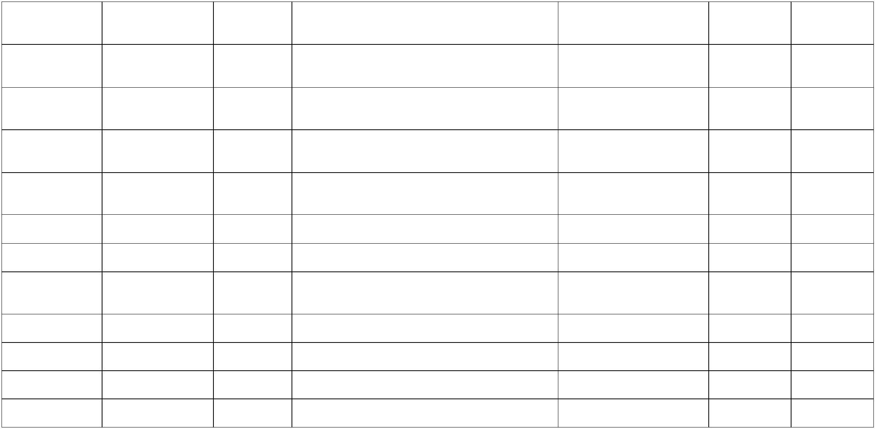Administrator Risk tolerant

USN-11

An administrator who Is handling the system Admin should monitor the Medium should update and take care of the application. records properly.

Sprint-2